|  |  |
| --- | --- |
| ***Introduction To Database*** | **Project Fall**  **2019-20** |

Project Name: Car Transportation Management System

**Course Teacher:** Kawser Irom Rushee

##### Section: E

**Group Members**

|  |  |
| --- | --- |
| **Name** | **ID** |
| **Ashraful Huda Rafi (19-39721-1)** | |
| **Munem Al Shahrair Sojib (19-39537-1)** | |

***Scenario:***

In a car Transportation Management System there is a CTMSUser. CTMSUser has a user id which is unique, user name, password, user type which has multiple values. User has a driver. One user has only Driver. Diver is known as Driver id ( primary key), driver name , Driver Gender, Driver D-O-B, Driver Address, licence no, driver phone which id multiple . User also has a Customer. One user has only one Customer. Customer is identified by Customer id which is unique, Customer name, Customer Gender, D-O-B, Address, and Customer Phone (multi valued).

Now one Driver owns many cars. Car is identified by Car id (unique), Car Model, Car Color, Capacity, Car Type. Cars are chosen for Ride. One car can chose One Ride at once. Also One Customer can Book one Ride at once. Also many Customers can pay for many Ride. Ride is identified by Ride id (Unique), Time, Destination, Pick up location, and drop off location, Fare.

## ER Diagram:

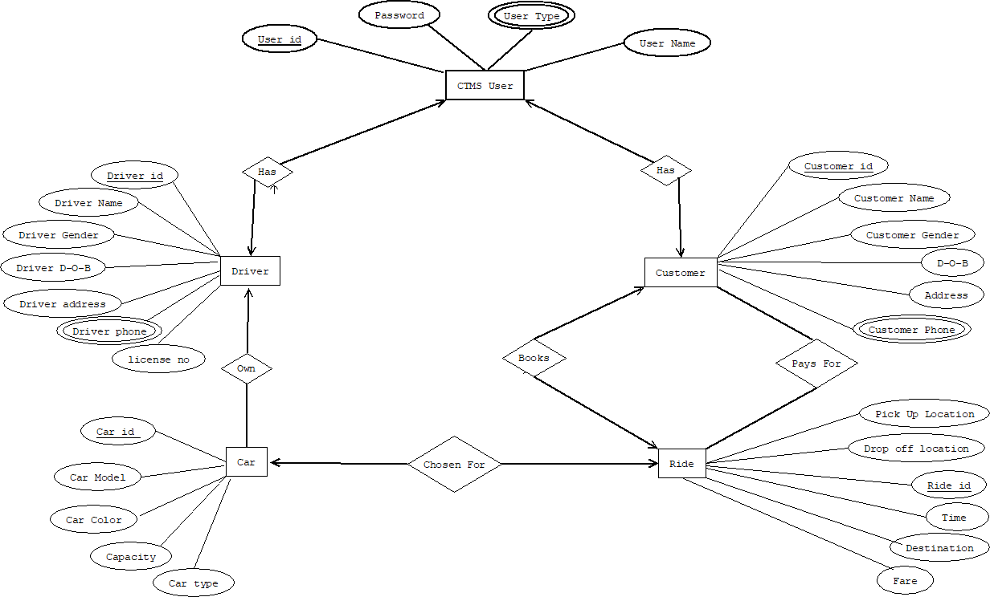

***Normalization:***

##### CTMSUser-----1----Has-----1 Driver

**UNF:** has ( User id **,** Password, User Name, User type, Driver Name, Driver id , Driver Gender, Driver D-O-B, Driver address, Driver phone , License no)

**1NF:** here User type and Driver phone are multivalued attribute

**1st:** User id, User name, password, user type ,

Driver id, Driver name, Driver Gender, Driver D-O-B, Driver address,

License no, Driver phone

##### 2NF:

**1st:**User id , password, User Name, User type .

**2nd:** Driver id, Driver name, Driver Gender, Driver D-O-B, Driver address, License no, Driver phone.

**3NF:** No transitive dependency

**1st:** User id , password, User Name, User type .

**2nd:** Driver id, Driver name, Driver Gender, Driver D-O-B, Driver address, License no, Driver phone.

### Table Creation:

**1st:** User id, password, User Name, User type .

**2nd:** Driver id, Driver name, Driver Gender, Driver D-O-B, Driver address, License no, Driver phone, User id, User Type.

### CTMSUser-----1----has------1 Customer

**UNF: :** has ( User id **,** Password, User Name, User type, Customer Name, Customer id , Customer Gender, Customer D-O-B, Address, Customer phone )

**1NF:** here User type and Driver phone are multivalued attribute.

**1st:** User id, User name, password, user type,

Customer id, Customer name, Customer Gender, Customer D-O-B,

Address, Customer phone.

**2NF:**

**1st:** User id, User name, password, user type

**2nd:** Customer id, Customer name, Customer Gender, Customer D-O-B, Address, Customer phone.

**3NF:** No transitive dependency

**1st:** User id, User name, password, user type

**2nd:** Customer id, Customer name, Customer Gender, Customer D-O-B, Address, Customer phone.

### Table Creation:

**1:** User id, User name, password, user type

**2:** Customer id, Customer name, Customer Gender, Customer D-O- B, Address, Customer phone, User id, User type.

### Driver-----1----owns----* Car

**UNF:** Owns(Driver Name, Driver id , Driver Gender, Driver D-O-B, Driver address, Driver phone , License no, Car id, Car color, Car type, Car model, Capacity)

**1NF:** Diver phone no is multivalued

**1st:** Driver Name, Driver id, Driver Gender, Driver D-O-B, Driver address, Driver phone, License no, Car id, Car color, Car type, Car model, Capacity.

# 2NF:

**1st:** Driver Name, Driver id , Driver Gender, Driver D-O-B, Driver address, Driver phone , License no.

**2nd:** Car id, Car color, Car type, Car model, Capacity.

**3NF:** No transitive dependency**.**

**1st:** Driver Name, Driver id, Driver Gender, Driver D-O-B, Driver address, Driver phone , License no.

**2nd:** Car id, Car color, Car type, Car model, Capacity.

### Table Creation:

**1st:** Driver Name, Driver id , Driver Gender, Driver D-O-B, Driver address, Driver phone , License no.

**2nd:** Car id, Car color, Car type, Car model, Capacity, Driver id, Driver phone.

### Car----1----chosen for---1 Ride

**UNF:** Chosen for (Car id, Car color, Car type, Car model, Capacity, Ride id, Pick up location, Drop off location, Time, Distance, fare)

**1NF:** No multivalued attributes

**1st:** Car id, Car color, Car type, Car model, Capacity, Ride id, Pick up location, Drop off location, Time, Distance, fare

### 2NF:

**1st:** Car id, Car color, Car type, Car model, Capacity.

**2nd:** Ride id, Pick up location, Drop off location, Time, Distance, fare.

**3NF:** No transitive dependency.

**1st:** Car id, Car color, Car type, Car model, Capacity.

**2nd:** Ride id, Pick up location, Drop off location, Time, Distance, fare

### Table Creation:

**1st:** Car id, Car color, Car type, Car model, Capacity.

**2nd:** Ride id, Pick up location, Drop off location, Time, Distance, fare, Car id.

### Customer-----1----Books-----1 Ride

**UNF:** Books(Customer Name, Customer id , Customer Gender, Customer D-O-B, Address, Customer phone, Ride id, Pick up location, Drop off location, Time, Distance, fare)

**1NF:** Customer phone is multivalued.

**1st:** Customer Name, Customer id , Customer Gender, Customer D-O- B, Address, Customer phone, Ride id, Pick up location, Drop off location, Time, Distance, fare.

### 2NF:

**1st:** Customer Name, Customer id , Customer Gender, Customer D-O- B, Address, Customer phone .

**2nd:** Customer phone, Ride id, Pick up location, Drop off location, Time, Distance, fare

#### **3NF:** no transitive dependency

**1st:** Customer Name, Customer id , Customer Gender, Customer D-O- B, Address, Customer phone .

**2nd:** Customer phone, Ride id, Pick up location, Drop off location, Time, Distance, fare

### Table Creation:

**1st:** Customer Name, Customer id , Customer Gender, Customer D-O- B, Address, Customer phone .

**2nd:** Ride id, Pick up location, Drop off location, Time, Distance, fare, Customer id, Customer phone.

### Customer-----*----Pays for----* Ride

**UNF:** Pays for (Customer Name, Customer id , Customer Gender, Customer D-O-B, Address, Customer phone, Ride id, Pick up location, Drop off location, Time, Distance, fare)

**1NF:** Customer phone is multivalued.

**1st:**Customer Name, Customer id , Customer Gender, Customer D-O- B, Address, Customer phone, Ride id, Pick up location, Drop off location, Time, Distance, fare.

### 2NF:

**1st:** Customer Name, Customer id , Customer Gender, Customer

D-O-B, Address, Customer phone .

**2nd:** Customer phone, Ride id, Pick up location, Drop off location, Time, Distance, fare

#### **3NF:** no transitive dependency

**1st:** Customer Name, Customer id , Customer Gender, Customer D-O- B, Address, Customer phone .

**2nd:** Customer phone, Ride id, Pick up location, Drop off location, Time, Distance, fare

### Table Creation:

**1st:** Customer Name, Customer id , Customer Gender, Customer D-O- B, Address, Customer phone .

**2nd:**Ride id, Pick up location, Drop off location, Time, Distance, fare, Customer id, Customer phone.

# Final Table:

**1:** User id, password, User Name, User type .

**2:** Driver id, Driver name, Driver Gender, Driver D-O-B, Driver address, License no, Driver phone, User id, User Type.

**3:** Customer id, Customer name, Customer Gender, Customer D-O-B, Address, Customer phone, User id, User type.

**4:** Car id, Car color, Car type, Car model, Capacity, Driver id, Driver phone.

**5:** Ride id, Pick up location, Drop off location, Time, Distance, fare, Customer id, Customer phone, Car id.

# Create Table Query:

1: create table CTMSUser(User_id number(20),Password Varchar2(100),User_name varchar2(100),User_type varchar2(40),constraint pk5 primary key(User_id,User_type));

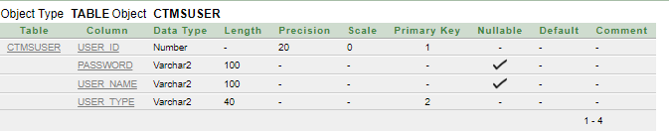

2: create table Driver(Driver_id number(20),Driver_name varchar2(100),Driver_gender varchar2(20),Driver_D_O_B date,Driver_address varchar2(200),Driver_phone number(20),User_id number(20),User_type Varchar2(40),constraint pk6 primary key(Driver_id,Driver_phone),constraint fk6 foreign key(User_id,User_type) references CTMSUser(User_id,User_type));

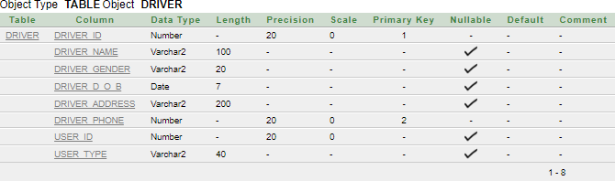

**3**: create table Customer(Customer_id number(20),Customer_name varchar2(100),Customer_gender varchar2(50),Customer_D_O_B date,Address Varchar2(200),Customer_phone number(20),User_id number(20),User_type varchar2(40),constraint pk7 primary key(Customer_id,Customer_phone),constraint fk7 foreign key(User_id,User_type) references CTMSUser(User_id,User_type));

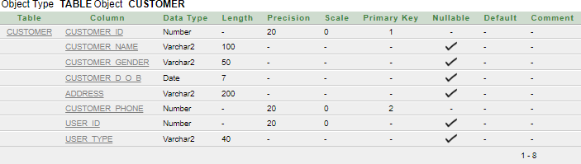

4: create table Car(Car_id number(20),Car_color Varchar2(100),Car_type varchar2(100),Car_model varchar2(100),Capacity Number(20),Driver_id number(20),Driver_phone number(20),constraint pk8 primary key(Car_id),constraint fk8 foreign key(Driver_id,Driver_phone) references Driver(Driver_id,Driver_phone));

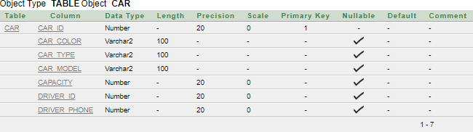

5: Create table Ride(Ride_id number(20),Pickup_location varchar2(100),Dropoff_location varchar2(100),Time varchar2(100),Distance varchar2(50),Fare varchar2(50),Customer_id number(20),Customer_phone number(20),Car_id number(20),constraint pk9 primary key(Ride_id),constraint fk9 foreign key(Customer_id,Customer_phone) references Customer(Customer_id,Customer_phone),constraint fk10 foreign key(Ride_id) references Car(Car_id));

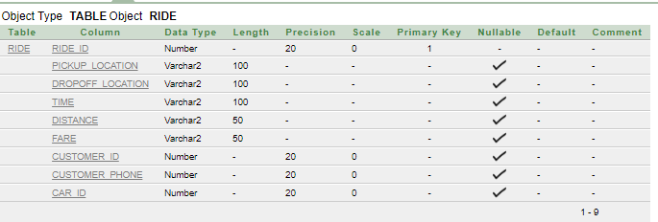

##### Insertion:

**1:**CTMSUser: insert into ctmsuser values('1834653','9999','Akash khan','Customer'); insert into ctmsuser values('1834654','10000','Bokul khan','Driver');

insert into ctmsuser values('1834655','10001','Md Ridy','Driver');

insert into ctmsuser values('1834656','10002','kamal Rahman','Customer'); insert into ctmsuser values('1834657','10003','Shathi Begum','Customer'); insert into ctmsuser values('1834658','10004','Jony khan','Driver');

insert into ctmsuser values('1834659','10005','RonyRedowan','Driver'); insert into ctmsuser values('1834660','10006','Mokles Rahman','Customer');

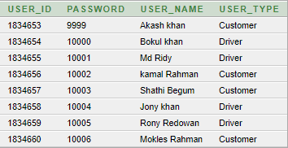

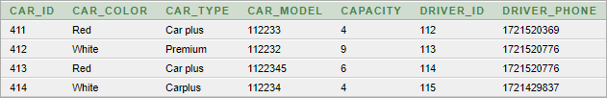**2:**Driver: insert into driver values('112','Md Ridy','Male','23-JAN- 1997','Gazipur,Dhaka','01721520369','1834655','Driver');

insert into driver values('113','Bakul khan','Male','23-JAN- 1995','Kuratoli,Dhaka','01721520776','1834654','Driver');

insert into driver values('114','Jonykhan','Male','23-JAN- 1995','Kuratoli,Dhaka','01721520776','1834658','Driver');

insert into driver values('115','Rony Redowan','Male','02-DEC- 1995','Pallabi,Dhaka','01721429837','1834659','Driver');

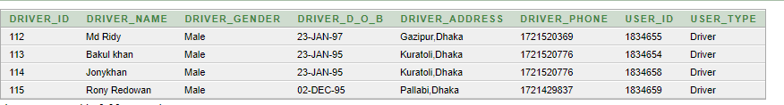

**3:**Customer: create table Customer(Customer_id number(20),Customer_name varchar2(100),Customer_gender varchar2(50),Customer_D_O_B date,Address Varchar2(200),Customer_phone number(20),User_id number(20),User_type varchar2(40),constraint pk7 primary key(Customer_id,Customer_phone),constraint fk7 foreign key(User_id,User_type) references CTMSUser(User_id,User_type));

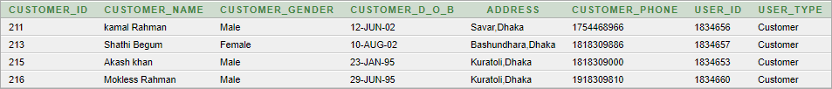

**4:**Car: insert into car values('411','Red','Car plus','112233','4','112','01721520369'); insert into car values('412','White','Premium','112232','9','113','01721520776'); insert into car values('413','Red','Car plus','1122345','6','114','01721520776'); insert into car values('414','White','Carplus','112234','4','115','01721429837');

**5:**Ride: insert into ride values('311','Dhanmondi','Kuratoli','1hr','13.2km','350','211','01754468966','411');

insert into ride values('312','Mirpur','NewMarket','2.2hr','7km','300','213','01818309886','412');

insert into ride values('313','kalshi','Jatrabari','3hr','14km','200','215','01818309000','413');

insert into ride values('314','Azimpur','Badda','1.7hr','12km','250','216','01918309810','414');

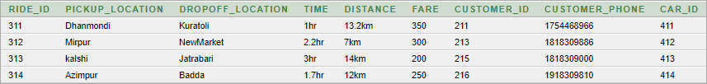

## Query: (join)

**1:** Display user name,user id, customer name, customer D-O-B,where the customer is in Basundhara.(Equijoin)

ANS:select u.user_Name,u.user_id,c.customer_name,c.customer_d_o_b,c.address from ctmsuser u,customer c where u.user_id=c.user_id and c.address like 'Bashundhara%'.



**2:** Create a query to display the customer name and CUSTOMER_D_O_B of any customer who was born after customer Akash khan.(selfjoin)

Ans: select e.customer_name,e.customer_d_o_b from customer e, customer a where a.customer_name='Akash khan' and e.user_type=a.user_type and a.customer_d_o_b<e.customer_d_o_b;

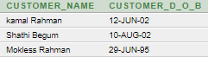

**3:** Display ride id,fare and fare range (Non equijoin)

Ans: select r.ride_id,r.fare,f.range from ride r,farerange f where r.fare between f.lowfare and f.hifare

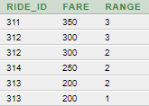

***4:*** Display user_name,user_type,driver_id,driver_phone,user_id whose user_type is driver.

Ans: select c.user_name,c.user_type,d.driver_id,d.driver_phone,d.user_id from ctmsuser c, driver d where c.user_id=d.user_id(+) order by c.user_id;

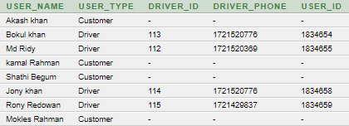

**5:** create a query to display User_Name,User_Id,Driver_D_O_B ,Driver_Address.(Equijoin)

Ans: select c.user_name,c.user_id,d.driver_d_o_b ,d.driver_address from ctmsuser c,driver d where c.user_id=d.user_id;

[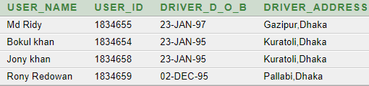](https://www.facebook.com/ashrafulhuda.rafi.58)

## Sub query:

**1:** Display the ride details whose fare is greater than 200.

Ans: select* from ride where fare>(select fare from ride where fare=200)



**2:** Display the car id along with their capacity where the car is having second lowest capacity.

Ans: select car_id,capacity from car where capacity=(select min(capacity) from car where capacity>(select min(capacity) from car))



## View:

1:create view which shows driver id,driver name,car id,car model.

Ans: create view info as select d.driver_id,d.driver_name,c.car_id,c.car_model from driver d,car c where d.driver_id=c.driver_id with read only;

select* from info

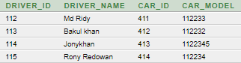

# Enable disable query:

**1:** Enable and dis able primary key constraint.

alter table farerange enable constraint pk10(Range is primary key)

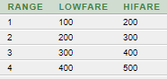

alter table farerange Disable constraint pk10

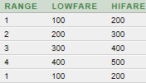

## Relational Algebra:

**1: (Projection)**

**Q**:Show the passwords of the user

Πpassword(Ctmsuser)

**2: (Selection with projection)**

**Q**:Find user id of the customers from Ctmsuser.

Πuser_id(σuser_type=’Customer’(Ctmsuser))

**Addition(** for showing non equijoin query I have created Farerange table **)**

create table farerange(range number(20),lowfare varchar2(100), hifare varchar2(100),constraint pk10 primary key(range));

desc fare_level;

insert into farerange values('1','100','200') insert into farerange values('2','200','300') insert into farerange values('3','300','400') insert into farerange values('4','400','500')